DS1500

- Can be issued to patients with terminal illnesses (defined for this purpose as 'a progressive disease where death as a consequence of that disease can reasonably be expected within 6 months’)
- Allows patients to claim Disability Living Allowance (DLA), Attendance Allowance (AA) or Incapacity Benefit (IB) under ‘special rules’. Under normal rules, people have to be in need of care for a period of time before they can make a claim for these benefits. Under special rules, patients can make a claim for DLA or AA without having to meet the qualifying period and can claim these benefits at the higher rates even if they do not need help looking after themselves. For IB patients can claim the higher rate after 28 weeks rather than 52 weeks.

- The form asks only for factual information from which the department of work and pensions (DWP) can make an assessment. It does not require us to give a prognosis.
- The report should contain information on:
  - The diagnosis
  - Whether the patient is aware of their condition (an if not, the details of the patient’s representative who is requesting the DS1500)
  - Relevant current and proposed treatment
  - Clinical findings
- This is not a claim form. An appropriate claim form must be submitted with the special rule box ticked.
- The DWP makes an assessment as to whether it is appropriate for a patient to receive these benefits under special rules. Just because a DS1500 has been completed, there is no guarantee that it will be accepted. If it is not accepted then the decision can be appealed.

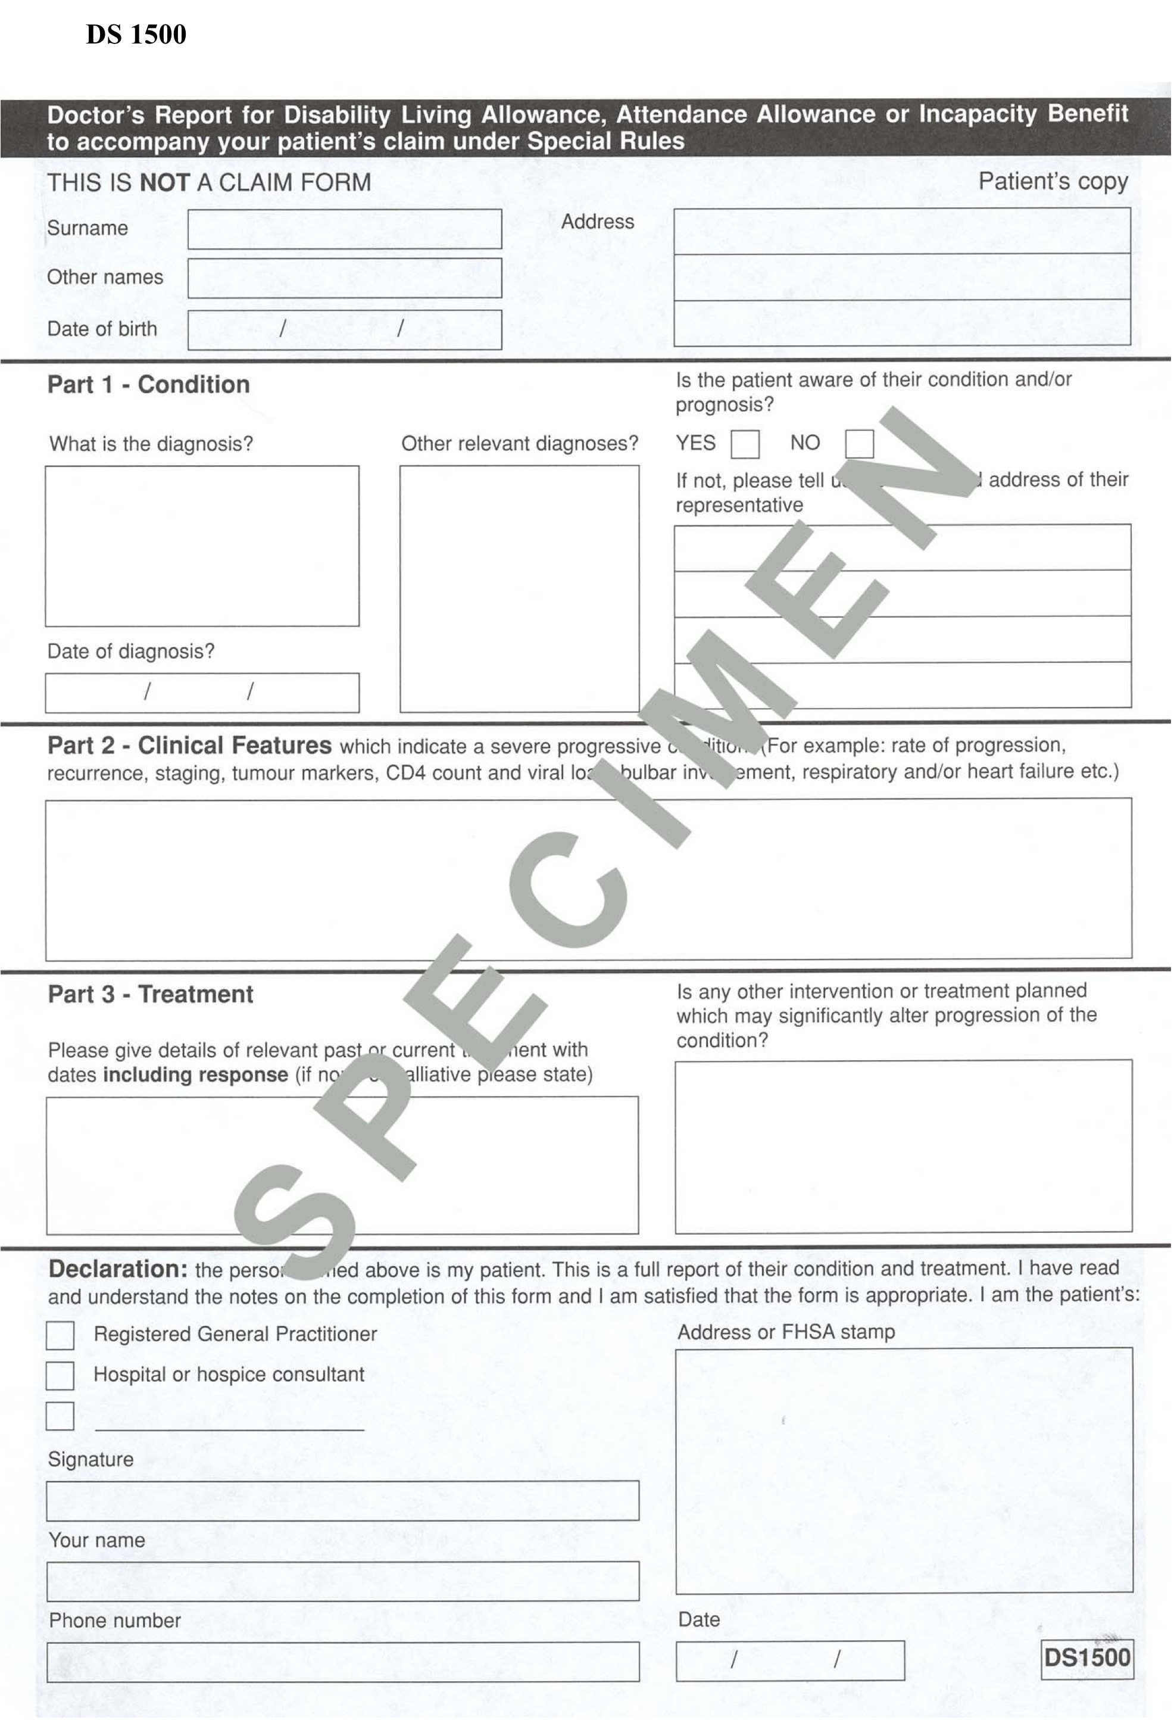
Fast Track/Priority Care

Continuing Care
- NHS continuing healthcare is a package of services which is arranged and funded by the NHS for adults outside hospital with ongoing health needs. Continuing healthcare can be delivered in any setting, including a person’s own home or in a care home.
- NHS Continuing Healthcare is free, unlike help from Local Authority Adult Services for which a charge may be made depending on a person’s income and savings.
- Usually applications go through an initial screening process and then full assessment.

Fast Track/Priority Care
- From October 1st 2007 the National Framework for NHS Continuing Healthcare and NHS Funded Nursing Care was implemented. There are no longer “levels” of Continuing Care.
- The previously termed “level 6” patients are now entitled “priority patients” and are identified as: Individuals with a rapidly deteriorating condition which may be entering a terminal phase…and will require immediate provision of NHS Continuing Healthcare because they need an urgent package of care. This may be supported by a prognosis if available but strict time limits are not relevant for end of life cares and should not be imposed.
- These patients will be “fast-tracked”, thus preventing any delay in care provision.
- The consultant or GP must outline the reasons for this decision using the Priority Patient form. It is their responsibility to make a decision based on the relevant facts of the case.

